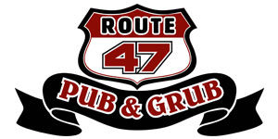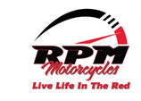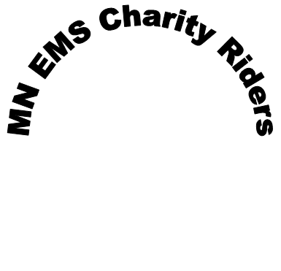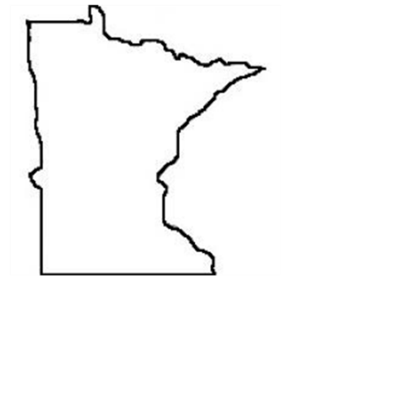

*Registration starts 9 am at Route 65 Pub and Grub, 18407 Hwy 65 East Bethel, MN 55011 (breakfast avail. 8 am, on your own). Presentation of colors and bike blessings begin at 10:30 am, with kick stands up promptly at 11 am. Win door prizes at rest stops throughout the day. Ride will be ending approximately 5 pm for dinner, time with family and friends, silent auction, door prizes, major prize drawings, and dancing.*

*(Music starts at 8:30 pm)*

*$25 per bike*

*Join us for*

***MN EMS Charity Riders***

***3rd Annual Motorcycle Tour***

***June 1st, 2024***

The Minnesota EMS Charity Riders is a 501(c)3 Non-Profit Organization that provides support to first responders including Paramedics, Emergency Medical Technicians (EMTs), Emergency Medical Responders (EMRs) and their immediate families in time of need. Our mission is to support those who have helped you by serving their communities in the EMS field and have experienced a life changing event. The Minnesota EMS Charity Riders rely on the generous donations by the community to provide support to these families.

**Supporting those who help you**

[www.mnemscharityriders.org](http://www.mnemscharityriders.org)

Follow us on Facebook: MN EMS Charity Riders

[mnemscharityriders@gmail.com](mailto:mnemscharityriders@gmail.com)